Role: franchise admin

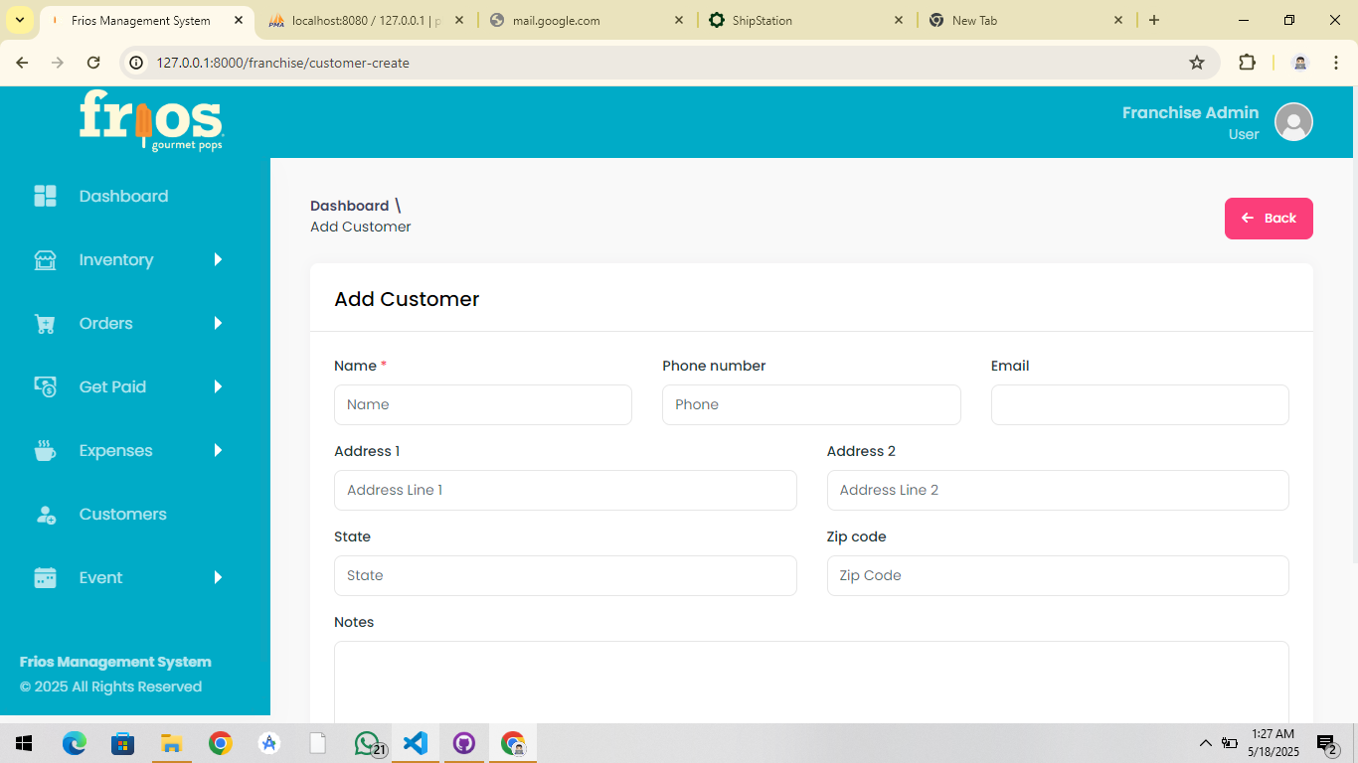  
email should be required now, because we have to send invoice on his email! ✔

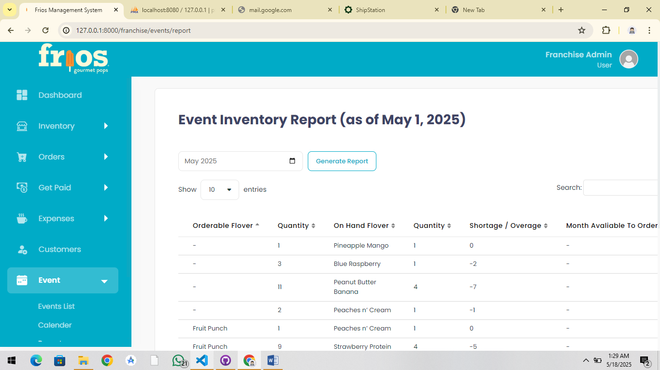  
  
report event page alignment! ✖

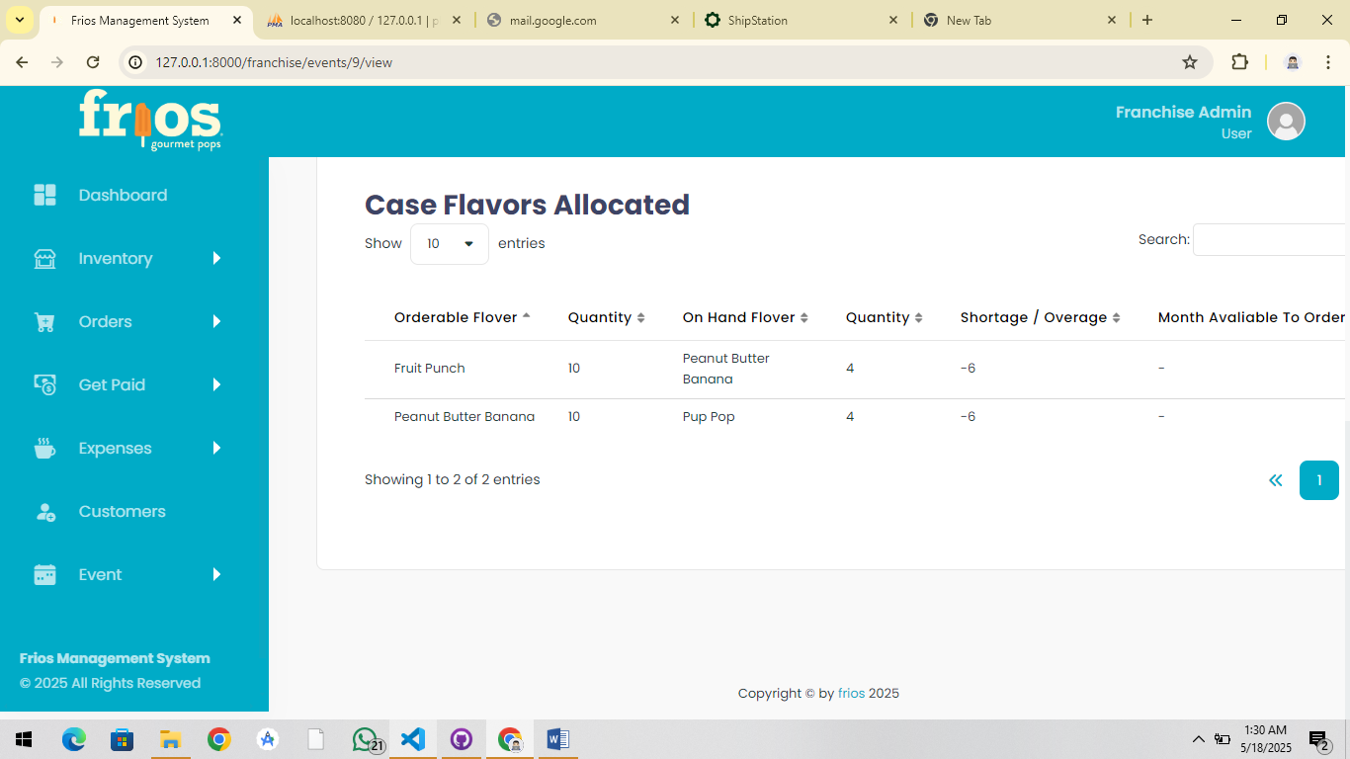  
  
view event page alignment fixing. ✖

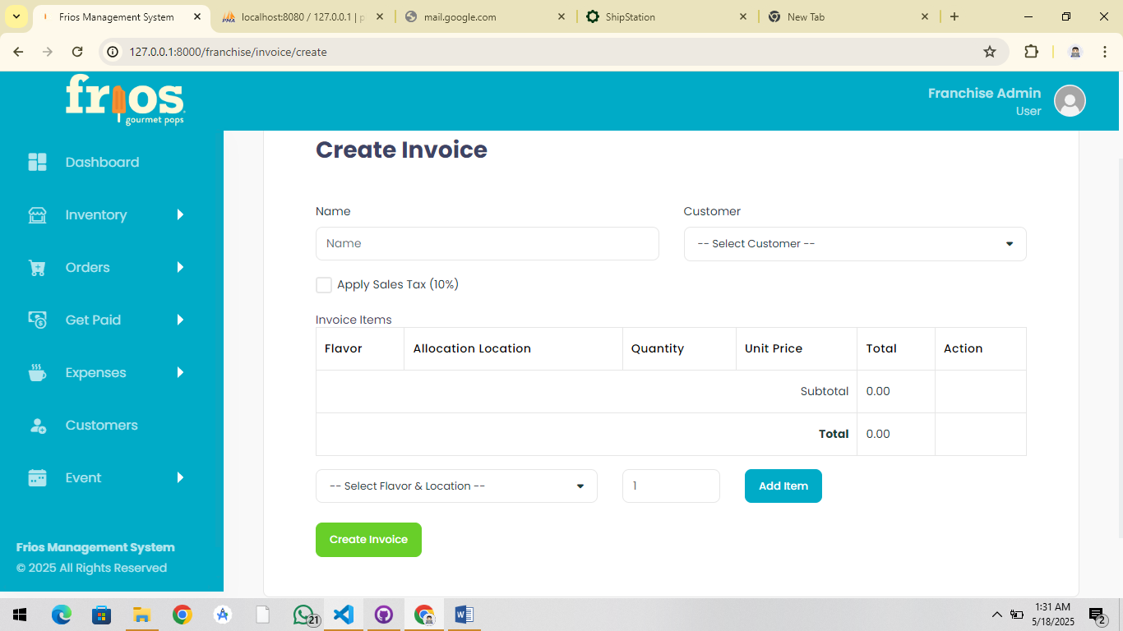  
  
invoice creation should be change, that I explained to fahad but its incomplete. ✔

I will share create invoice page with you (and the logic is every item should have checkbox for add tax for each if we check any of checkbox of item tax should add in total amount and tax is defined by user in text field below).

Users selection dropdown is nullable but if we select the customer by dropdown the invoice pdf should send to the customer email so he can payment for the event .

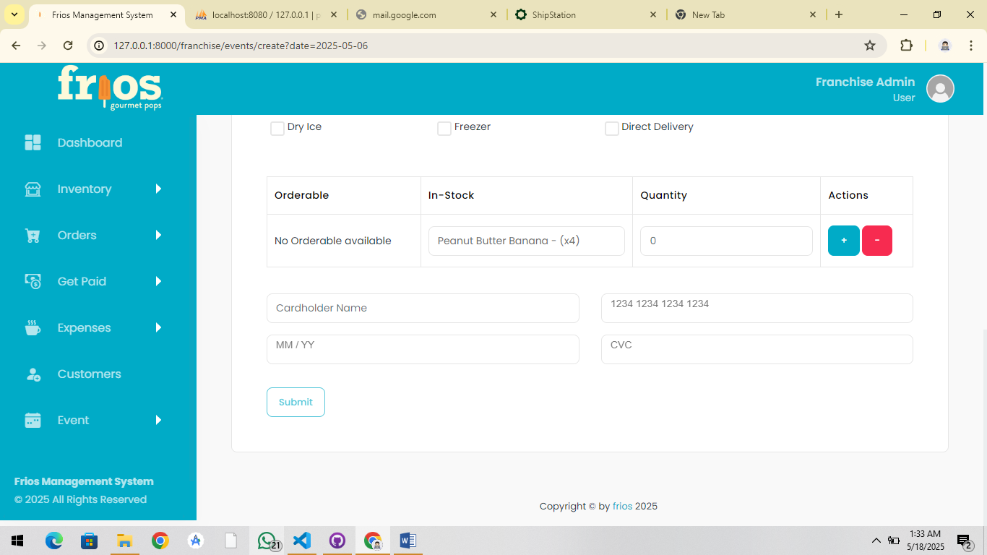  
  
remove card detail in everywhere in the system cause we have to use other approach for detect the amount. ✖

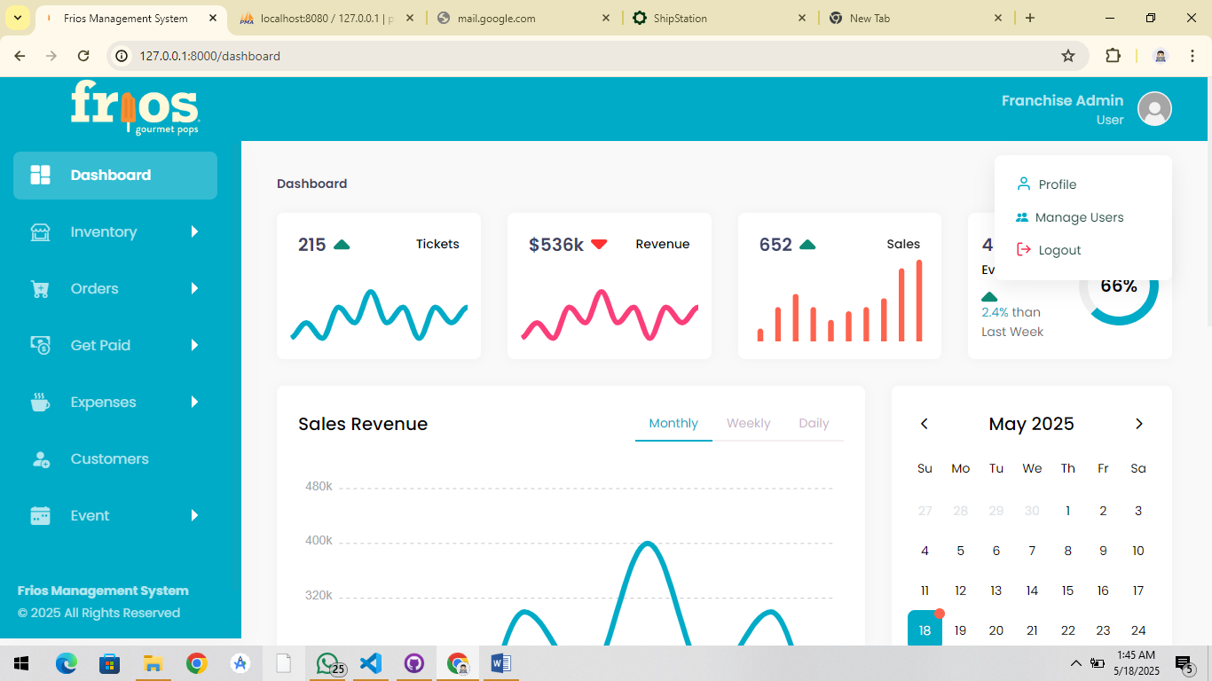

In this dropdown add link which in add payment and when admins click on it the form should open to add stripe account for sending and receiving of the amount in admins bank account( payment account connection is just for franchise admin role). ✔

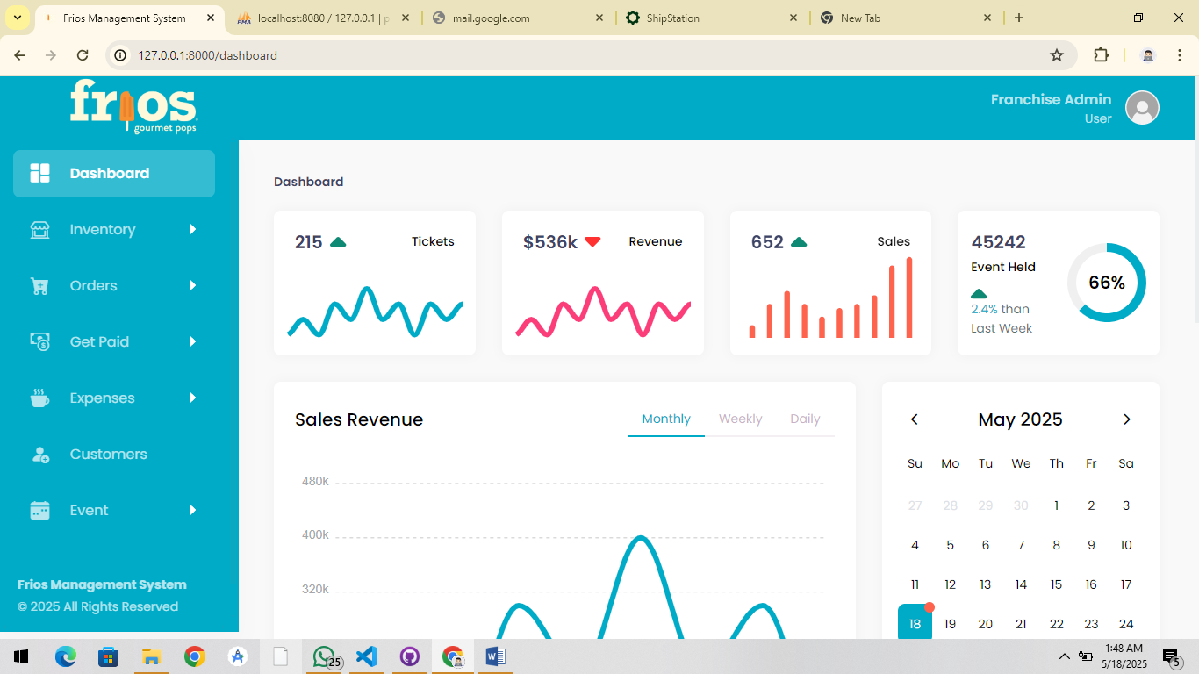  
  
this index page of all role (corporate admin, franchise admin, franchise manager, franchise staff) going to the dynamic data (corporate admin can see over all data by franchises, franchise admin and manager see their data on index page of their own franchise, staff don’t see the sales but they can see events numbers, up coming events data like that of their own franchise).

Role: franchise staff:  
  
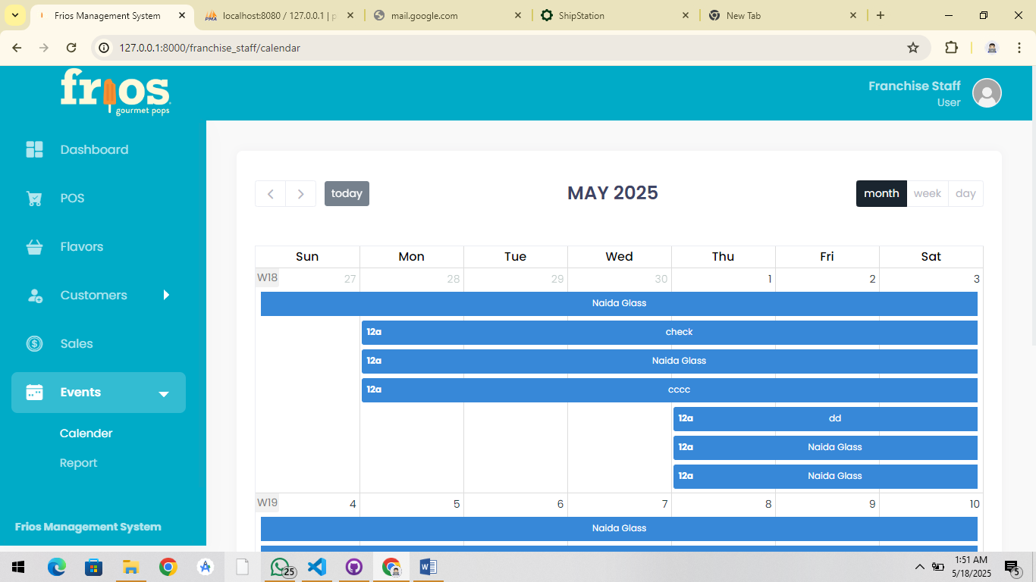

Report button is missing in calendar view for staff so add button here same as like franchise admin calendar view. ✖

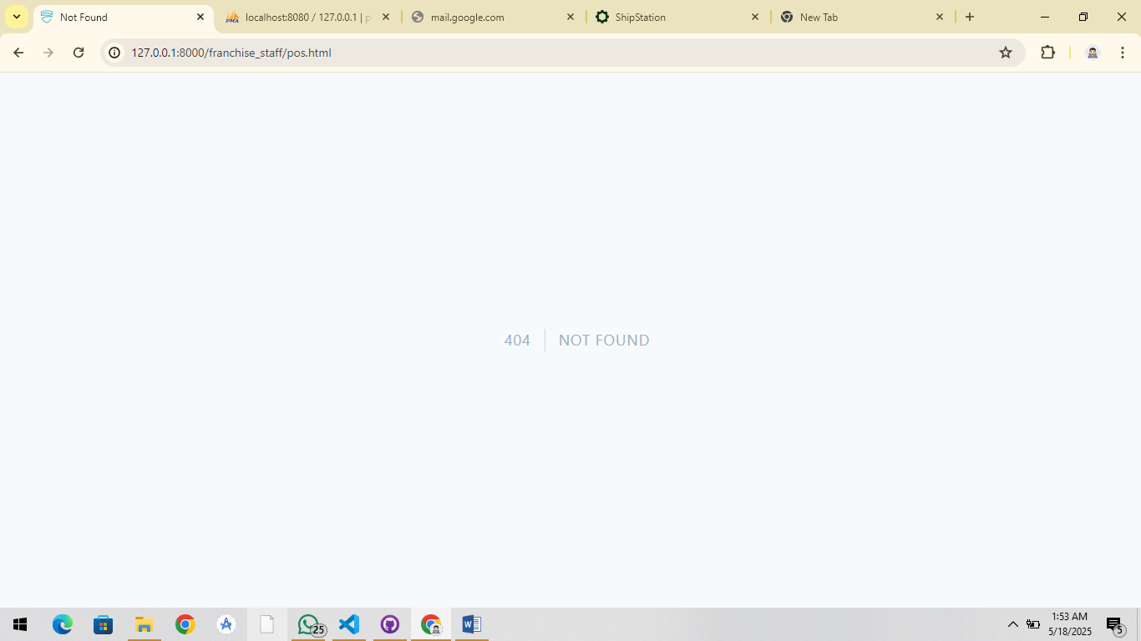  
pos is missing in staff ✖

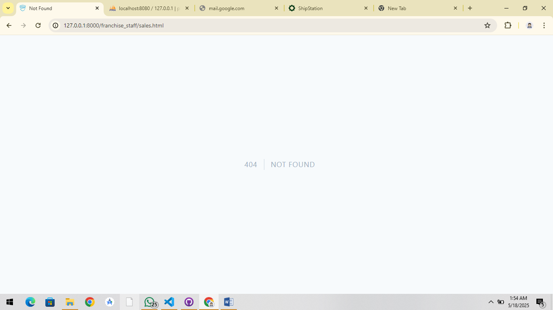  
  
sales is missing in staff page (in sales just we have to display item which is sold by franchise of its own not sales/payement). ✖

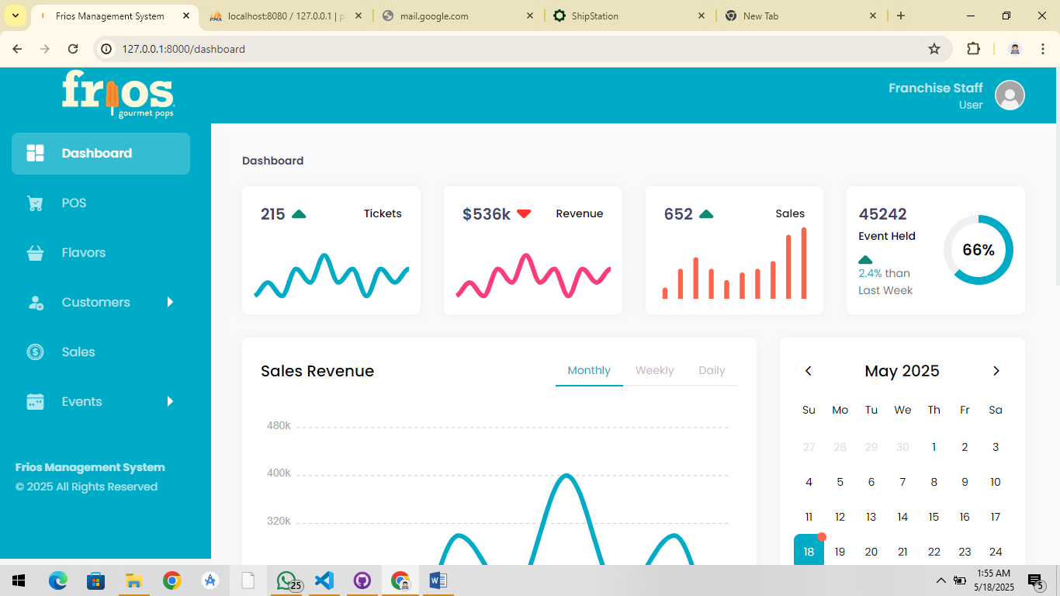  
  
index page should be dynamic data for staff

Corporate admin role:

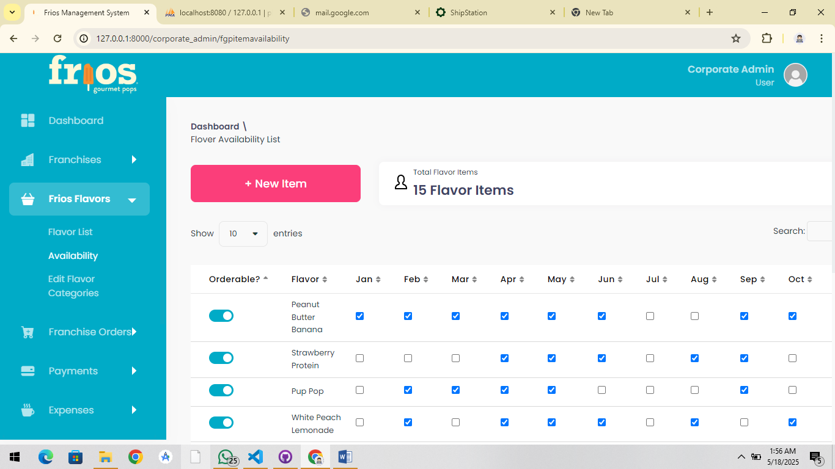  
  
 fix alignment of this page on corporate view.✖

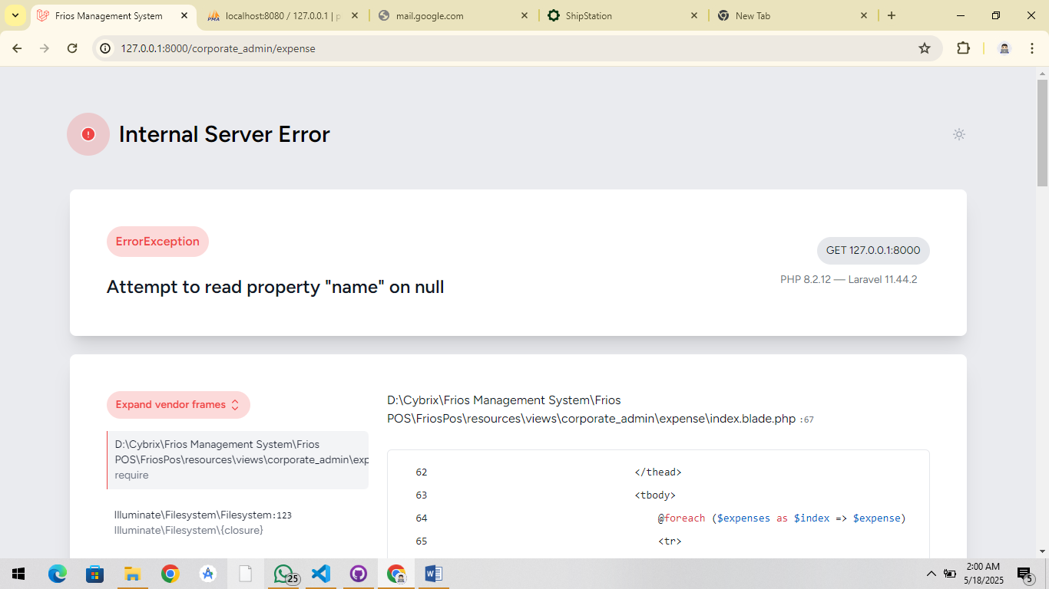  
  
got this when I click this link……. ✔

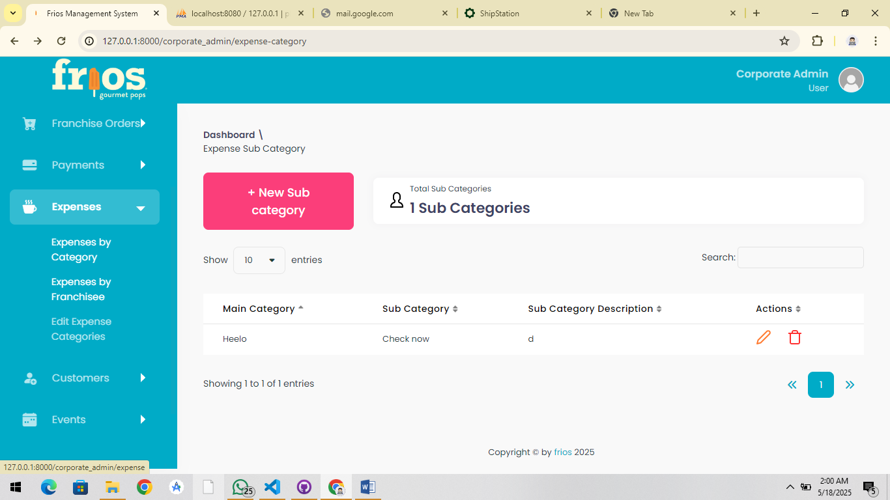

(expenses by franchises) so cant test! ✔

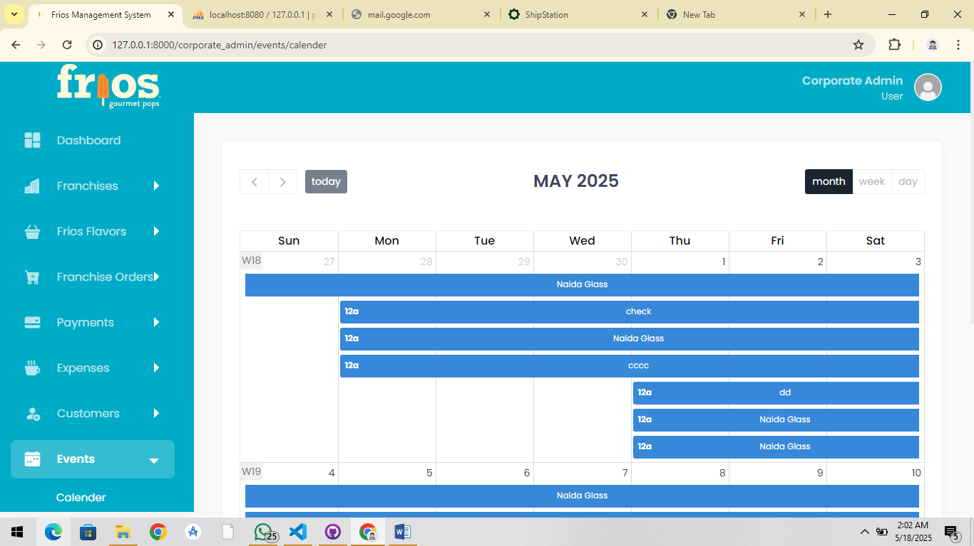  
  
report button is missing on corporate admin calendar view page. ✖

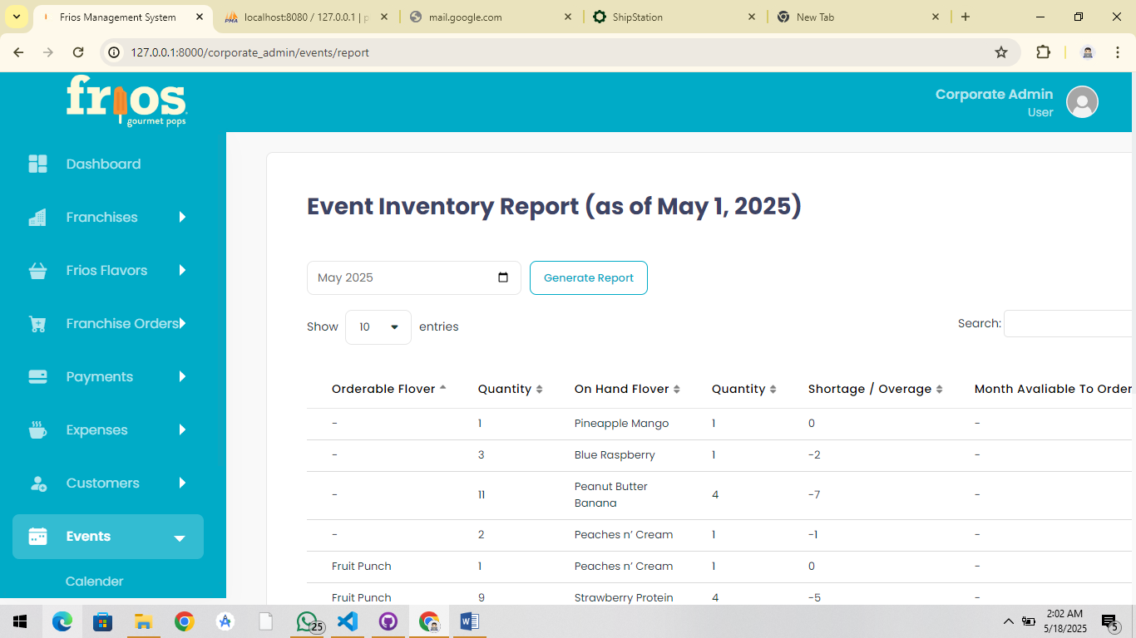  
  
fix the alignment of this page. ✖

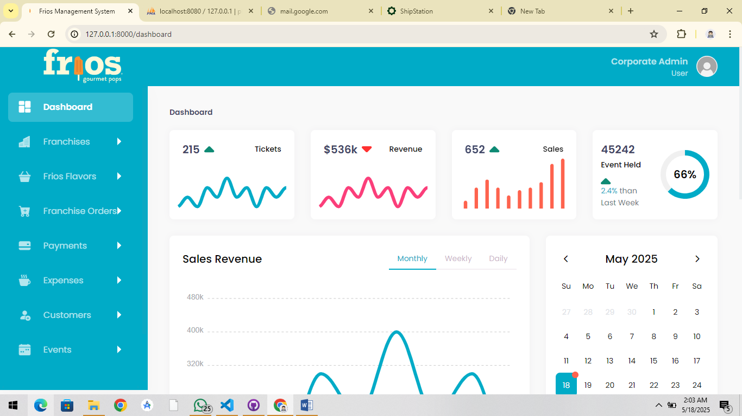  
  
make this page dynamic for corporate admin.✔

detail description:

1. Event & Payment

• No payment is needed when creating an event.

• In the POS, he wants to be able to link a sale to a specific event, like a session.

• Example: If you’re selling pops at a festival, every sale at that event should be tagged to it.

• Some events may have just one invoice instead of many POS sales.

⸻

2. Expenses

• Don’t send emails for expenses.

• Expenses are just for record keeping, like paying staff, rent, etc.

• Corporate admin does not need emails or alerts for these.

⸻

3. Corporate Admin

• Corporate Admin should only see reports (sales and expenses by each franchise).

• Corporate Admin is not involved in franchise POS or invoice sales.

⸻

4. Tax in Invoice

• Each invoice line item should have a “Taxable” checkbox.

• At the bottom of the invoice, there should be:

• A text field to enter tax percentage (e.g., 8.5%)

• System should only apply tax to taxable items

• Display total tax separately and store tax amount and final total in DB.

⸻

5. Invoice Email

• If an event has a linked customer, and an invoice is created, email the invoice PDF to the customer.

⸻

6. Stripe Setup

• Franchise Admins should have a place to connect their Stripe account.

• For now, you can use a simple text input for Stripe keys or setup data.

• Only Franchise Admins can set this up (not Managers or Staff).

⸻

7. Payment & POS

• Don’t add a payment method to event creation.

• Payment (card) can be handled in the POS page or when paying an invoice.

• Later, when you build the React Native app, it should:

• Connect to this Laravel backend

• Use features like: inventory, user access, and currently running events

• Support tap-to-pay or card reader usage

⸻

8. POS Use Case

• The web POS is for:

• Simple card processing (e.g., when someone calls in with a card)

• Tagging the sale to an event

• The React Native POS app will be used at events for quick customer checkout.

⸻

9. Invoice After Franchise Orders

• When a Franchise places a pop order from Corporate, auto-generate an invoice.

• That invoice acts as a record of what the Franchise needs to pay.

• You can treat this like an “Expense Transaction”.

⸻

10. Dashboard (Homepage)

• For Franchise Admin/Manager:

• Show upcoming events

• Show sales and expenses from last month

• Show a basic inventory list

• Staff might see limited info (exclude sales)

• ACH (Automated Clearing House) is a bank-to-bank transfer method.

• It’s used for direct debit or direct deposit (like paying bills directly from a bank account).

• He wants Franchisees to pay Corporate for their pop orders using ACH — not credit card — because:

• ACH is cheaper (very low or no transaction fees compared to Stripe’s card fees).

• It only requires a one-time setup where both Franchisee and Corporate connect their bank accounts.

• He shared Stripe’s ACH documentation because he wants this built using Stripe ACH Direct Debit.

• He believes Laravel Cashier (Stripe) already supports ACH, which should simplify the integration.

⸻

So to implement this:

• Franchisee would need to link their bank account (using Stripe).

• Then when they place a pop order, the payment is automatically pulled from their bank via ACH and sent to Corporate.

<https://docs.stripe.com/payments/ach-direct-debit>

<https://docs.stripe.com/payments/bank-debits>

- Customer Email Requirement for Invoicing Previously, only the customer’s name was required. But now, to support invoice emailing, we’ll make the email field required when creating a customer.

• When an invoice is created for a customer, we will send them a PDF copy of the invoice via email.

• Along with the PDF, there will be a “Pay Now” button that redirects the customer to Stripe’s payment page, where they can pay the invoice directly.

- Franchise Stripe Account SetupWhen a Franchise Admin logs in, they will be required to connect their Stripe account (by entering their Secret Key and Publishable Key) before performing any transactions such as:

• Placing pop orders

If they attempt any of these actions without connecting Stripe, we’ll display a message:

“Please connect your Stripe account first.”

Once connected:

• Order payments will be automatically deducted from the franchise’s Stripe account and sent to Corporate.

Franchise Admins will be able to update or change their Stripe keys anytime.

However, we won’t be validating if the keys are valid at the time of entry, but the system will handle errors if any invalid keys are used during an actual transaction.

- Corporate Admin AccessCorporate Admin will:

• Not receive payments directly via POS or invoices

• Be able to view all incoming payments from franchisees (orders, expenses, events, etc.)

Event payments will go to the franchises accounts

• Have reporting access to track all payments made by each franchise

- Event Payments from Customers

When a customer pays for an event:

• The payment will go directly to the connected franchise’s Stripe account.

1. Stripe Setup on First Login

• As soon as a franchise admin logs in for the first time, they should be prompted to connect their Stripe account.

• This is important because any future payments (like ordering pops) will go through Stripe.

2. Expenses Are Not Paid via Stripe

• Normal business expenses (e.g. payroll, advertising, rent) do not go through Stripe they’re just record keeping entries in the system.

• No payment is actually processed when an expense is added (unlike orders or invoices).

3. Ordering Pops = Special Type of Expense

• When a franchise orders pops, this is a real payment that goes through Stripe, and the system should automatically record it as an expense.

• It should be categorized under:

• Category: Inventory & Supplies

• Vendor/Source: Frios’s Gourmet Pops

So, only pop orders (which involve payment) should trigger Stripe and also automatically get saved in the expenses list as a specific type of expense.